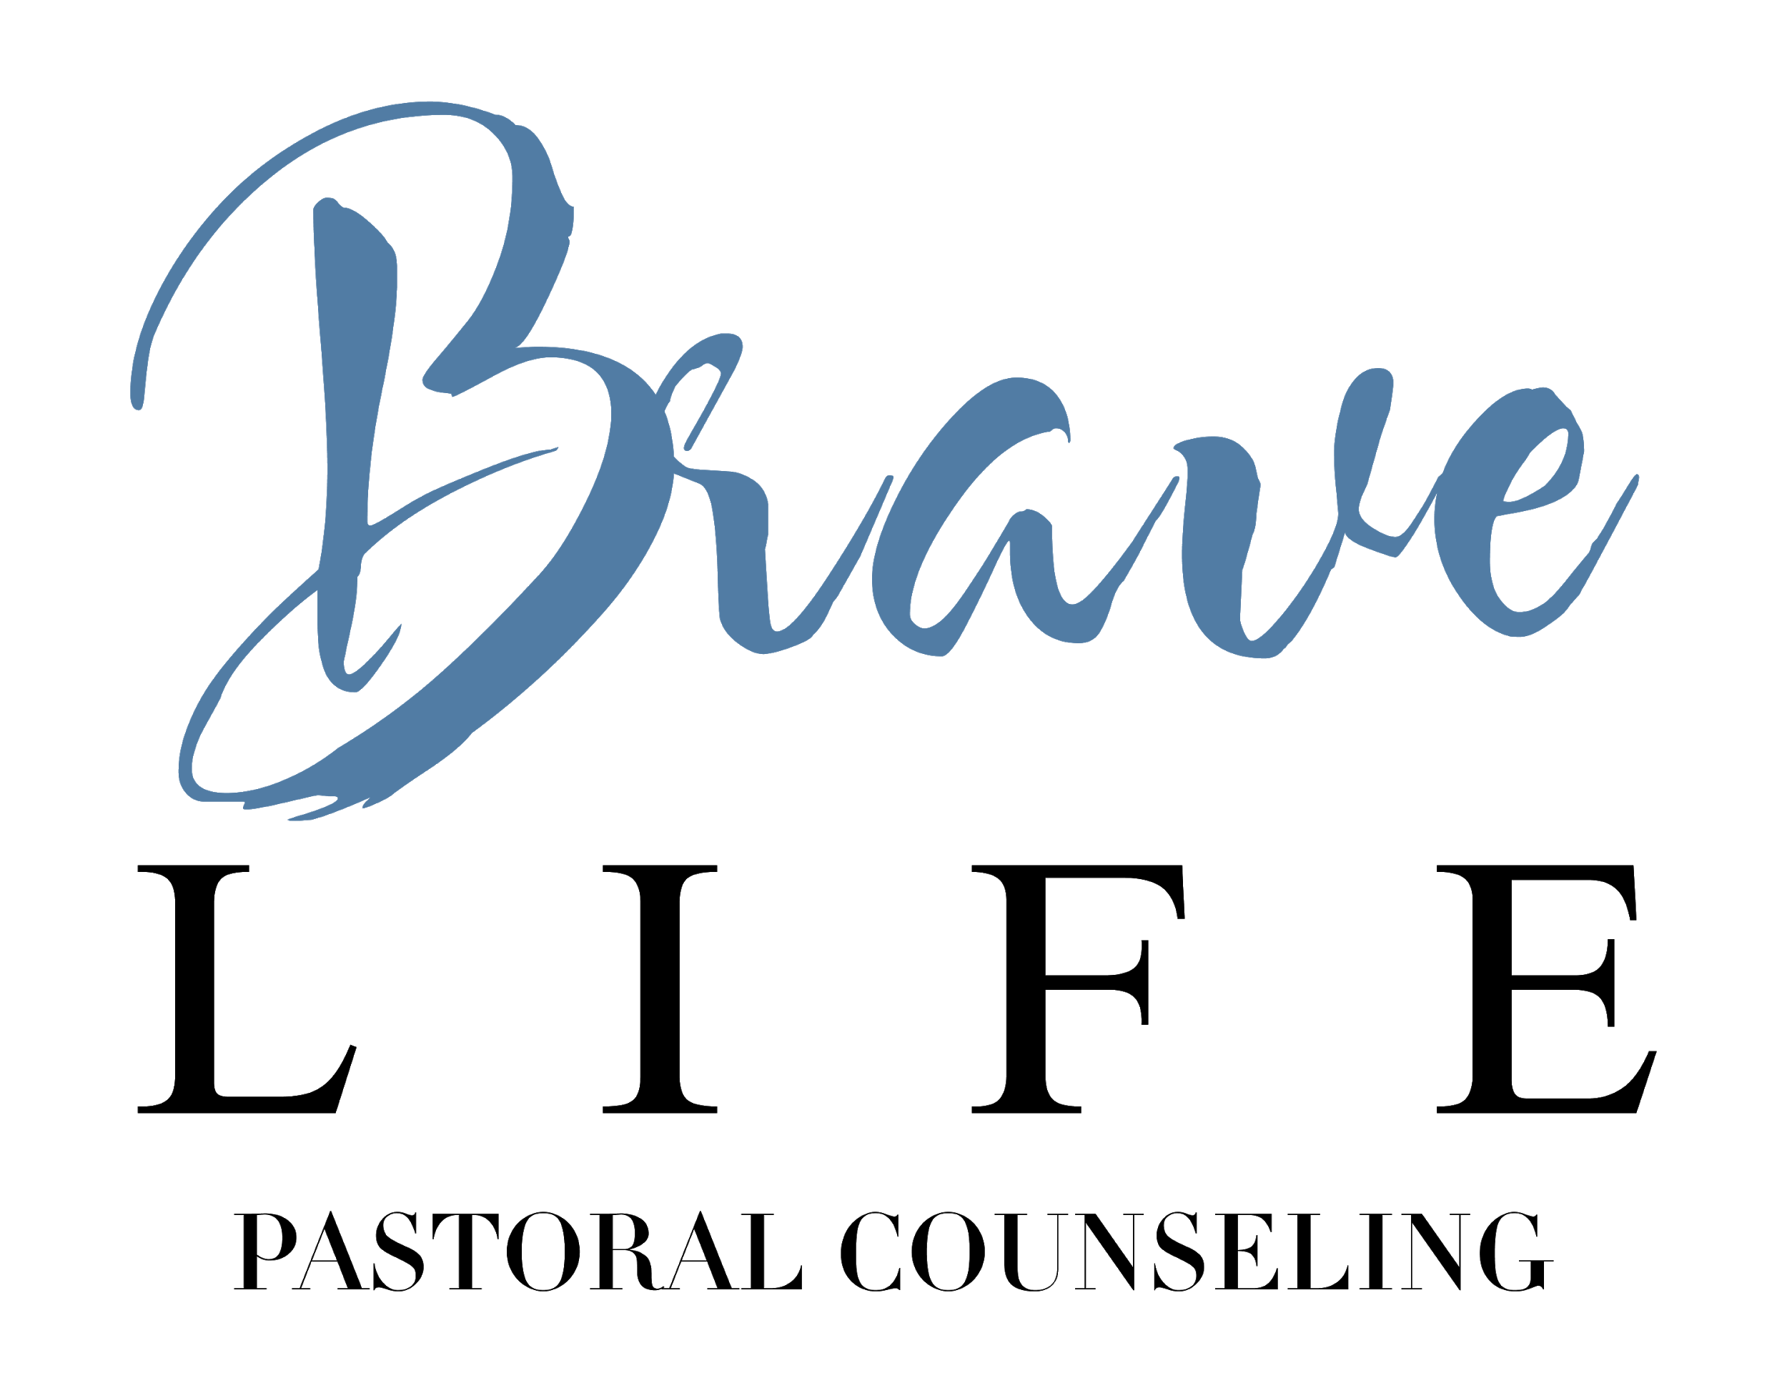
Welcome and thank you for choosing to work with Brave Life Pastoral Counseling. Brave Life Pastoral Counseling is a Christian counseling practice associated with the ministry of Champion City Vineyard Church. We are committed to providing quality biblical counseling that is holistically focused on our clients’ healing and restoration in Christ. The following form has been assembled in order to answer basic questions regarding the policies of the practice and to ensure the smooth operation of the counseling relationship. Please read through the document and provide your signature and the date as your agreement to the aforementioned terms and conditions.
____________________________________________________________________________
Counselor Qualifications

Derek Ellis (MAPC) is a 2016 graduate of Liberty University with a Master of Arts in Pastoral Counseling with a specialization in life coaching. He received his Bachelor of Arts in Psychology from Wittenberg University in 2012 and plans to pursue his doctorate in the future. Derek is a Board Certified Christian Counselor through the Board of Christian Professional and Pastoral Counselors, a professional organization associated with the American Association of Christian Counselors.

Derek currently serves as the counseling pastor at Champion City Church as well as the member of the staff teaching team. Derek was ordained as a minister within the Vineyard denomination in 2017. Brave Life Pastoral Counseling operates under the sponsorship and auspices of the elders of Champion City Church.

The Process

“Pastoral counseling, a clinical practice that integrates both psychological and theological concepts into its framework, is not unlike other modes of therapy when it comes to the therapeutic process. What sets it apart is the way the Christian faith, spirituality, and theology are incorporated into the model. Pastoral counselors believe this incorporation of spiritual exploration and support can foster wholeness, healing, and growth in those who are seeking help. Beyond providing psychotherapy, pastoral counselors utilize resources such as prayer, scripture study, and participation in the congregation community to help guide people on their journey toward transcendence, transformation, and greater connection to others.”

Since pastoral counselors are not licensed by the state to diagnoses mental illness, the primary modality of treatment involves extensive and intensive talk therapy alongside the aforementioned resources.

Confidentiality

Seeking mental health services is a brave, yet sensitive step towards wholeness and healing. At Brave Life Pastoral Counseling, we desire to honor your commitment through strict adherence to confidentiality practices. At the beginning of the counseling relationship, a client file will be maintained through an online database; this client file will not be shared with anyone outside of the primary pastoral counselor, with rare exceptions given to administrative staff and/or other counselors providing supervision and oversight to the primary counselor for the purpose of consultation and therapeutic efficacy.

You generally must provide written consent before information is shared with anyone outside of Brave Life Pastoral Counseling. An Authorization to Release Information has been included within this paper; if you know of anyone who you’d like the details of your case to be shared with, please add this information so that Brave Life Pastoral Counseling is aware of your preferences.

There are, however, some instances in which confidentiality must be broken. Your primary pastoral counselor is required by law to act as a mandated reporter in the following instances:

- Intent to harm self or another person
- If child abuse/neglect is suspected
- If elder abuse/neglect is suspected
- If abuse/neglect of a person with developmental disabilities is suspected

If there is a certain manner in which you wish to be contacted in order to maintain confidentiality, please notify your counselor promptly.

Appointments and Scheduling

At Brave Life Pastoral Counseling, we want to make scheduling appointments as simple and hassle-free as possible. There are three primary methodologies to scheduling appointments: phone calls to our office, at the end of each counseling session, or by way of email. We do not honor appointments left on the phone answering service. Appointments can be scheduled weekly, bi-weekly or monthly. The sessions will last 50 minutes.

Illnesses and emergencies are a natural part of life, so we understand the need to cancel appointments. If you are unable to keep an appointment, please call the office and leave a message. If you are unable to keep an appointment due to scheduling conflicts, 24 hour notice must be provided to avoid a full session charge for late cancellation or a missed appointment. This policy is not meant to be punitive but is instead designed to discourage missed appointments, since missed appointments deprive others the opportunity to receive counseling services.

Termination of Counseling Relationship
We seek to serve you as long as you feel that counseling is effective and worthwhile. While we believe that the counseling journey is best brought to resolution through discussing it with your counselor, you may terminate the counseling relationship at any time without any notice to the counselor.

Note: The counselor may recommend a referral if your specific needs would be best served by the expertise of another mental health professional. A list of recommended referral sources is available upon request.

Payment Policies

Since Brave Life Pastoral Counseling operates under the auspices of the local church, we are unable accept insurance or health care plans. Therefore, we require all clients to privately pay for all services. However, we have structured our private pay on a sliding fee scale in order to make the counseling services available and accessible to all people. See the chart below for the current fee schedule. If the current fee structure does not work for your current financial situation, please speak with your counselor promptly to craft a reasonable alternative payment amount.

Yearly Income | Fee Per Session
$0 - $35,000 | $40
$35,001 - $50,000 | $55
$50,001 - $65,000 | $70
$65,001 and higher | $85
Initial Intake Session | $85

Payments are to be received at the end of each session; sessions can be paid for by cash, check, or credit card. Counseling sessions will not be conducted if payment cannot be submitted at the end of the session. We will work with you to reschedule your session to a time when you are able to pay.
Emergencies

Brave Life Pastoral Counseling does not provide 24/7 emergency or crisis services. While your counselor can typically be reached during the regular office hours, immediate responses to emergencies cannot be guaranteed. In the event of emergency or if you are in need of immediate help, please contact one of the following 24-hour crisis phone numbers. You will be able to speak with a trained counselor who will advise you as to your next steps:

Consolidated Care Crisis Hotline | 1-800-224-0422
Mental Health Services of Clark and Madison Counties, Inc. | 937-399-9500
Emergency Medical Assistance | 911
National Suicide Prevention Lifeline | 1-800-273-8255

Client Agreement

For our records, we ask that you sign this form to state that you have the terms and agree to the aforementioned policies: I have read and received a copy of this document and understand all its content.

___________________________________________________ ____________
Signature of Client or Legal Guardian Date

_________________________________________ ____________
Signature of Counselor at Brave Life Pastoral Counseling Date

http://www.goodtherapy.org/learn-about-therapy/modes/pastoral-counseling

