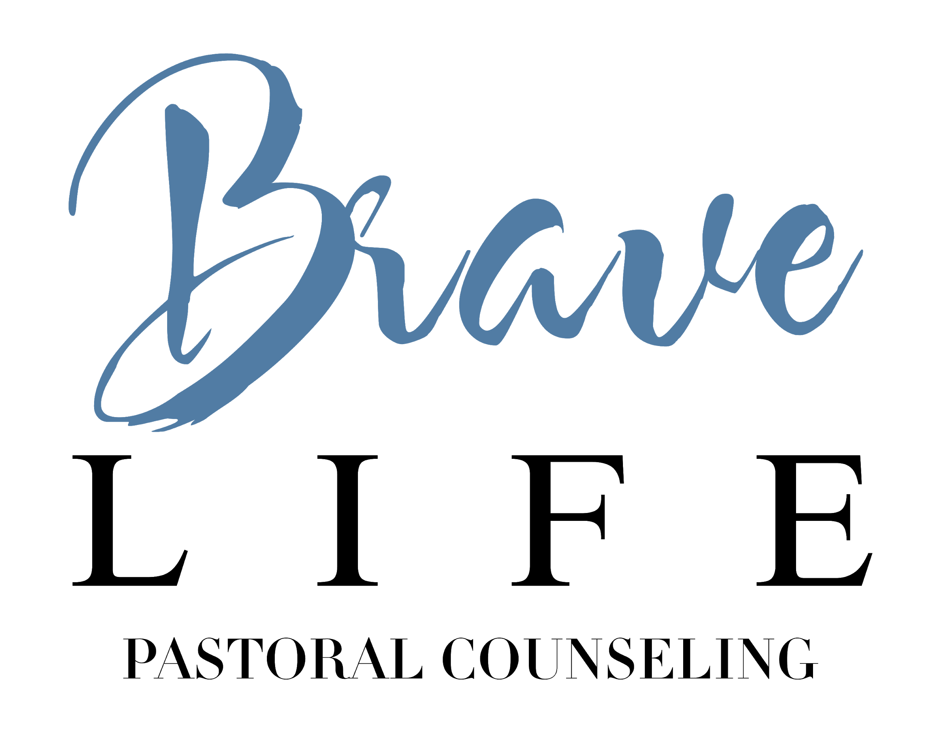
Welcome and thank you for choosing to work with Brave Life Pastoral Counseling. Brave Life Pastoral Counseling is a Christian counseling practice associated with the ministry of Champion City Vineyard Church. We are committed to providing quality biblical counseling that is holistically focused on our clients’ healing and restoration in Christ. The following form has been assembled in order to answer basic questions regarding the policies of the practice and to ensure the smooth operation of the counseling relationship. Please read through the document and provide your signature and the date as your agreement to the aforementioned terms and conditions.
____________________________________________________________________________

Confidentiality

Seeking mental health services is a brave, yet sensitive step towards wholeness and healing. At Brave Life Pastoral Counseling, we desire to honor your commitment through strict adherence to confidentiality practices. At the beginning of the counseling relationship, a client file will be maintained through an online database; this client file will not be shared with anyone outside of the primary pastoral counselor, with rare exceptions given to administrative staff and/or other counselors providing supervision and oversight to the primary counselor for the purpose of consultation and therapeutic efficacy.

There are, however, some instances in which confidentiality must be broken. Your primary pastoral counselor is required by law to act as a mandated reporter in the following instances:

- Intent to harm self or another person
- If child abuse/neglect is suspected
- If elder abuse/neglect is suspected
- If abuse/neglect of a person with developmental disabilities is suspected

If there is a certain manner in which you wish to be contacted in order to maintain confidentiality, please notify your counselor promptly.

No Secrets Policy

When a couple enters into counseling, it is considered to be one unit. This means that my allegiance is to the couple “unit,” and not to either partner as individuals. I find this is particularly important in creating a space where both partners can feel safe. Therefore, I adhere to a strict “No Secrets” policy. This means that I will not hold secrets for either partner. This policy is intended to allow me to continue to treat the couple by preventing, to the extent possible, a conflict of interest to arise where an individual’s interests may not be consistent with the interests of the unit being treated. During the counseling process, individual partners may be seen for individual counseling. In this case, the individual session is still considered as part of the couple’s counseling relationship, with the express goal of working on individual issues that may impede the progress of the marriage counseling. Information disclosed during individual sessions may be relevant or even essential to the proper treatment of the couple. If an individual chooses to share such information with me, I will offer the individual every opportunity to disclose the relevant information and will provide guidance in this process. If the individual refuses to disclose this information within the couple’s session, I may determine that it is necessary to discontinue the counseling relationship with the couple. If there is information that an individual desires to address within a context of individual confidentiality, I will be happy to discuss this within the individual counseling session, with the understanding that this information will shared eventually within the context of the marriage counseling relationship. This policy is intended to maintain the integrity of the couples/marital counseling relationship.

Court Proceedings/Subpoena of Records

It is understood that the purpose of marital/couples therapy is for the amelioration of distress within a relationship. Therefore, if both partners request my services as a pastoral counselor, they are expected not to use information given to me during the therapy process against the other party in a judicial setting of any kind, be it civil, criminal, or circuit. Likewise, neither party shall for any reason attempt to subpoena my testimony or my records to be presented in a deposition or court hearing of any kind for any reason, such as a divorce case.

Release of Records

Both partners must provide their consent to release marital/couples counseling records. If one partner does not provide consent, records will not be released.

Course of Treatment

The continued participation by each person is voluntary. Either participant may suspend or terminate the therapy at her or his individual request. I certify by my signature below that I have read, fully understand, and agree to abide by the stated policies.

Appointments and Scheduling

At Brave Life Pastoral Counseling, we want to make scheduling appointments as simple and hassle-free as possible. There are three primary methodologies to scheduling appointments: phone calls to our office, at the end of each counseling session, or by way of email. We do not honor appointments left on the phone answering service. Appointments can be scheduled weekly, bi-weekly or monthly. The sessions will last 50 minutes.

Illnesses and emergencies are a natural part of life, so we understand the need to cancel appointments. If you are unable to keep an appointment, please call the office and leave a message. If you are unable to keep an appointment due to scheduling conflicts, 24 hour notice must be provided to avoid a full session charge for late cancellation or a missed appointment. This policy is not meant to be punitive but is instead designed to discourage missed appointments, since missed appointments deprive others the opportunity to receive counseling services.

Termination of Counseling Relationship
We seek to serve you as long as you feel that counseling is effective and worthwhile. While we believe that the counseling journey is best brought to resolution through discussing it with your counselor, you may terminate the counseling relationship at any time without any notice to the counselor.

Note: The counselor may recommend a referral if your specific needs would be best served by the expertise of another mental health professional. A list of recommended referral sources is available upon request.

Payment Policies

Since Brave Life Pastoral Counseling operates under the auspices of the local church, we are unable accept insurance or health care plans. Therefore, we require all clients to privately pay for all services. All sessions for marital counseling are $85. If this current fee structure does not work for your current financial situation, please speak with your counselor promptly to craft a reasonable alternative payment amount. Payments are to be received at the end of each session; sessions can be paid for by cash, check, or credit card. Counseling sessions will not be conducted if payment cannot be submitted at the end of the session. We will work with you to reschedule your session to a time when you are able to pay.
Emergencies

Brave Life Pastoral Counseling does not provide 24/7 emergency or crisis services. While your counselor can typically be reached during the regular office hours, immediate responses to emergencies cannot be guaranteed. In the event of emergency or if you are in need of immediate help, please contact one of the following 24-hour crisis phone numbers. You will be able to speak with a trained counselor who will advise you as to your next steps:

Consolidated Care Crisis Hotline | 1-800-224-0422
Mental Health Services of Clark and Madison Counties, Inc. | 937-399-9500
Emergency Medical Assistance | 911
National Suicide Prevention Lifeline | 1-800-273-8255

Client Agreement

For our records, we ask that you sign this form to state that you have the terms and agree to the aforementioned policies.

I have read and received a copy of this document and understand all its content.

_____________________________________________________________________________________________Signature of Client Print name Date of Birth Date Signed

_____________________________________________________________________________________________ Signature of Client Print name Date of Birth Date Signed

_____________________________________________________________________________________________Signature of Counselor Print Name Date Signed

